Car_Price Predicition Deployment

1.Create AWS Account

Enter your information
Add payment details
Verify Mobile Number
Choose Basic Support Plan
Login to AWS Management Console
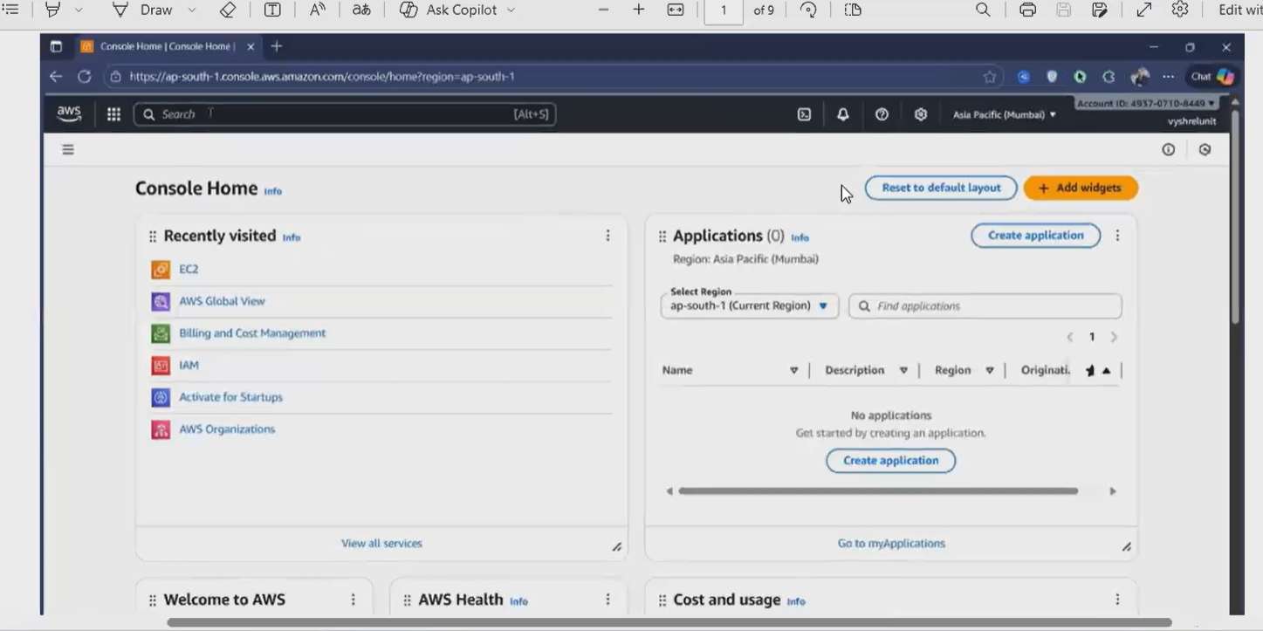

Inside that we can see EC2 (Virtual Server) For that payment needed
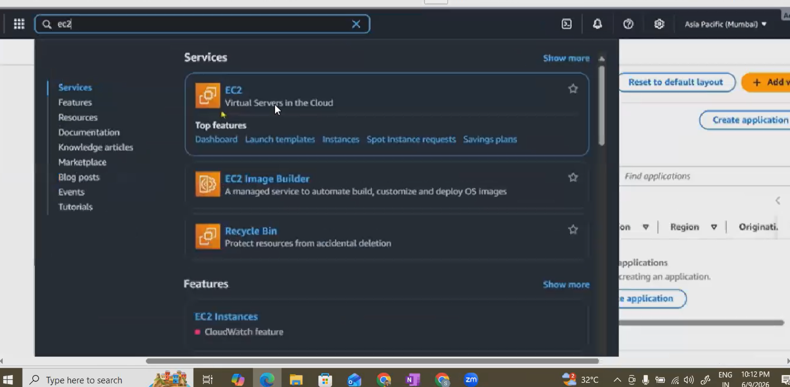

2.LAUNCH EC2 INSTANCE
In AWS Console search for EC2
Click Launch Instance
Name Car-Price-Prediction-Server
Choose AMI:Ubuntu Server 22.04 LTS
Instance type:t2.Micro(free tier Eligible) -STORAGE CONFIGURATION

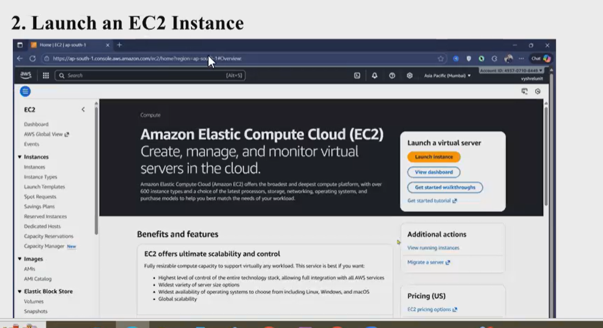

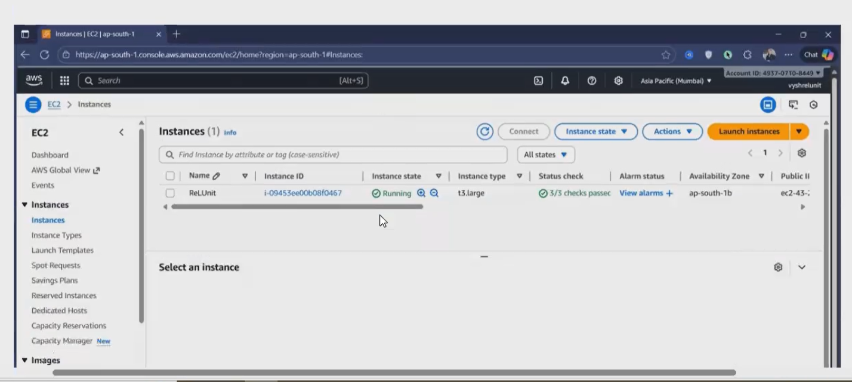

3.Create Key Pair
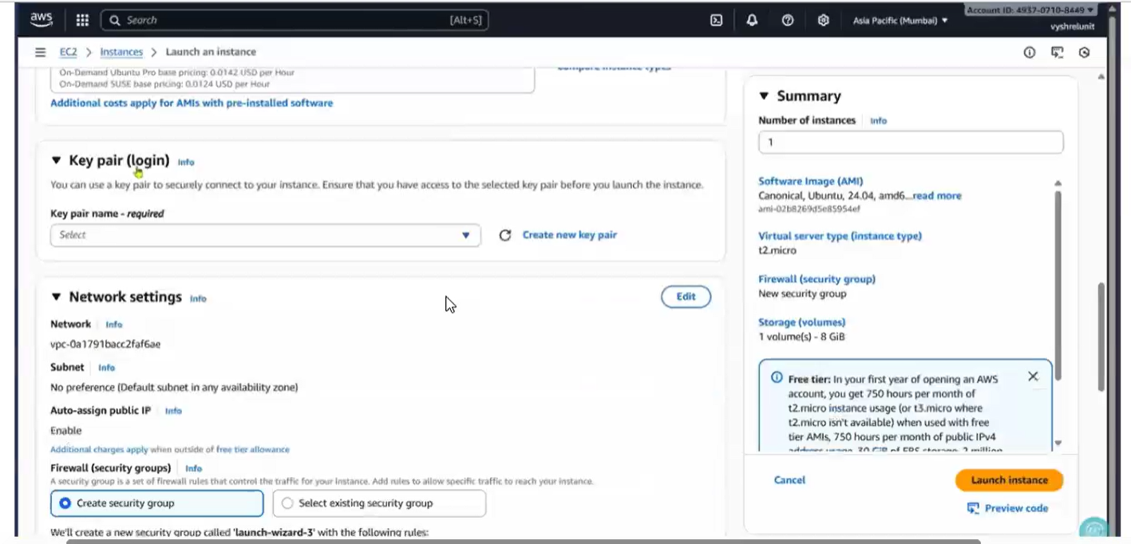

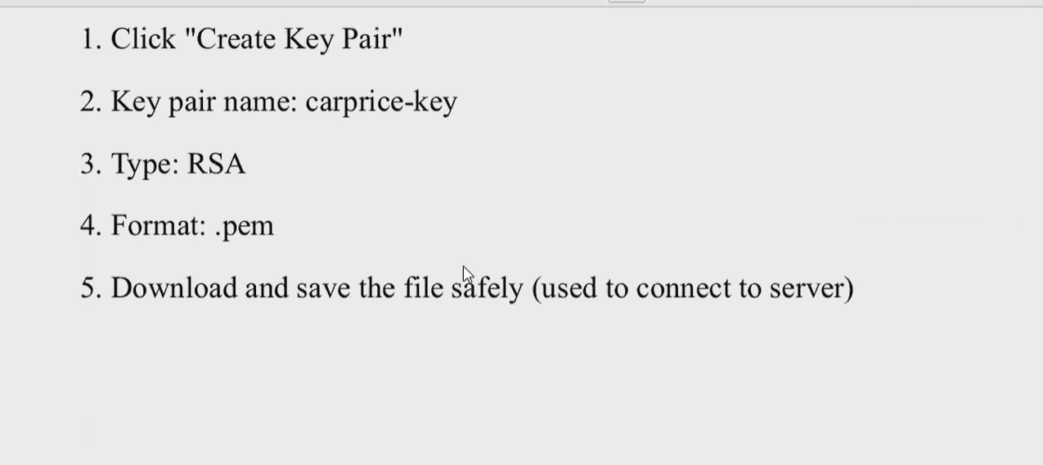

STORAGE CONFIGURATION
Choose Micro because it hourly base chargest if we forget to stop instances hr increase payment also increases.

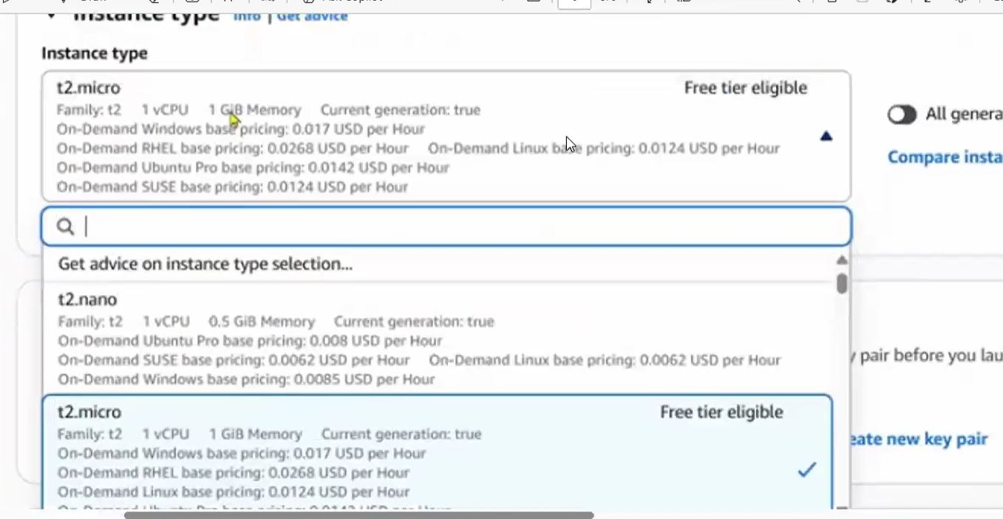

Leave the default storage settings
Main.py
Index.html
Random_forest_regression_model.pkl

INSTALL REQUIRED PYTHON LIBRARIES

Run
Pip3 install Flask
Python main.py

ACCESS THE WEB APPLICATIONS
Open a browser and go to
http://YOUR_PUBLIC_IP:5000
Example:
http://3.110.125.20:5000
Your car price Prediction web application will be visible
ARCHITECTURE OVERVIEW:
USER BROWSER

PUBLIC IP

AWS EC2 Server

Flask Application

Random Forest Pickle

Predicted Car Price

